`

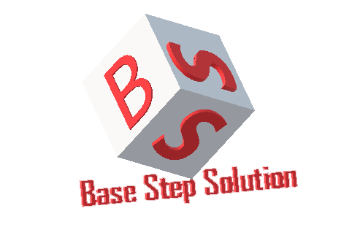

Meeting Minutes

Van Lang Admissions

# Revision Table

|  |  |  |  |
| --- | --- | --- | --- |
| **Author** | **Date** | **Reason for changes** | **Version** |
| Khoi Nguyen | 20/02/2017 | Initial Document | 1.0 |

Table of Contents

Revision Table 1

I. Purpose 3

II. Participant in meeting 3

III. Content of meeting 3

IV. To do task 5

|  |  |  |  |  |  |
| --- | --- | --- | --- | --- | --- |
| **Writer:** | Khởi Nguyễn | **Location:** | Room 701C | | |
| **Date:** | 20/02/2017 | **Start:** | 10h | **Finish:** | 11h15 |

# Purpose

* Prepare for EOMP 2

# participant in meeting

Mentor Vũ Thế Nam

Team Capston:

* Nguyễn Thái Hiền
* Nguyễn Hoàng Anh Tài
* Đoàn Anh Minh
* Trần Xuân Hải
* Nguyễn Anh Khởi

# Content of meeting

* Task assign : Devide into 3 sheet
* Manage efford
* What documents must to commit ?
* Review Testcase :
  + Update testcase
  + 3 role = 3 testcase = 3 view: Only list the items they have the right to see
  + How to show 3 roles have 3 different views
* Discuss the flow of Push news
* Tools resize image
* Review Schedule , Task assign , WBS
* Slide content : action item

# To do task

* Update document
* Prepare for EOMP 2

---- *** ----